Federated Learning-Based Smart Grid Demand Forecasting for Privacy-Preserving Energy Optimization

Harsh Agarwal
Department of Computing
Technologies
SRM Institute of Science and
Technology
Kattankulathur-603203, India
Email: ha1487@srmist.edu.in
Dr. Lavanya R*
Department of Computing
Technologies
SRM Institute of Science and
Technology
Kattankulathur-603203, India
Email: lavanyar@srmist.edu.in
Sriansu Patra
Department of Computing
Technologies
SRM Institute of Science and
Technology
Kattankulathur-603203, India
Email: sp4695@srmist.edu.in

Abstract— This paper proposes a federated learning-based smart grid demand forecasting system that enables privacy-preserving, scalable electricity usage analysis. The system relies on smart meter–level intelligence instead of centralized data collection. Load data at each smart meter is processed locally; only model parameters(weights) are shared with an aggregation server, which reduces data transfer and safeguards consumer privacy. A long short-term memory (LSTM) model is used for next-hour demand prediction using the past 24 hours of consumption. The system supports dual-mode operation: simulation (synthetic time-series data) and real hardware (e.g., ESP32 with non-intrusive current sensing). Real-time load status and forecast results are reported to a web-based monitoring dashboard. The system enables secure, efficient, and privacy-aware smart grid operation by eliminating centralized raw data aggregation.
Keywords: Federated learning, smart grid, demand forecasting, LSTM, privacy preservation, smart meter, non-intrusive sensing, edge computing.

Introduction

The smart grid, an innovative aspect of traditional power systems, allows for intelligent monitoring and management of electricity consumption. As smart meters are continuously deployed, data is continuously generated for electricity consumption. Although such data supports improved demand analysis and grid planning, centralized data collection presents problems such as consumer privacy, communication overhead, and scalability. This paper presents a Federated Learning–Based Smart Grid Demand Monitoring and Forecasting system for better energy management without user privacy breach. Rather than central processing, intelligence is distributed over smart meter nodes. Every node processes the electricity consumption data locally instead of the central server, which guarantees that sensitive information is not directly shared. The system provides non-intrusive current sensing technology that does not directly touch live electrical lines, making it safe to measure power consumption. Local edge processing units examine load conditions and engage in federated learning, sharing only model parameters. Each node trains a local LSTM model on its own data; only model weights are sent to the aggregation server. The server runs Federated Averaging (FedAvg) to produce a global model that is then redistributed to nodes for the next round. The aggregated model enables effective demand monitoring and
forecasting while maintaining data privacy. A monitoring dashboard
gives real-time visibility of grid conditions, supporting the operation of a smart grid securely, scalably, and efficiently.

LITERATURE SURVEY

Recent advances have included technologies in smart meters, cloud platforms, and data analytics methods to improve energy management, demand monitoring, and grid planning in smart grid systems. Some works investigate centralized machine learning approaches for load forecasting based on centralized storage of large data onto cloud servers. These approaches have made major improvements in forecasting accuracy and grid planning but suffer significant limitations, such as constant data transmission, centralization of data storage, constraints in scalability and in the reliability of the system. Although helpful, centralized smart grid solutions often have serious repercussions on data privacy and security. Consumer energy usage information has been considered sensitive data in many studies and provides insight into the behaviour patterns of individuals. Risk factors mentioned in the literature include unauthorized access, data leakage, and cyber-attacks resulting from dependence on cloud and wireless communication channels [2], [3], [5]. This has triggered the call for distributed, privacy-preserving learning mechanisms.

To overcome such challenges, federated learning has gained interest as a scalable solution for distributed data analysis. McMahan et al. [1] proposed federated learning with Federated Averaging (FedAvg), where model training is performed on edge devices without sharing raw data. Subsequent research has utilized federated learning for smart grid environments for load forecasting and energy optimization, achieving reduced communication overhead and improved privacy protection compared to centralized methods [4], [5], [17]. Edge computing and lightweight learning models for real-time energy monitoring have also been proposed in recent works [4], [5], [13]. However, current solutions often treat forecasting, privacy preservation, and real-time monitoring as independent systems. In general, existing literature addresses individual aspects such as demand prediction, data privacy, or distributed learning; yet few have addressed an integrated framework that combines real-time sensing, federated LSTM-based forecasting, edge processing, and privacy-preserving communication. This proposed system seeks to fill this gap by linking these components into a fully integrated smart grid demand monitoring and forecasting architecture.

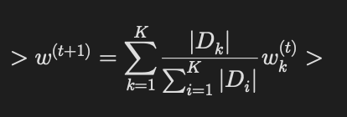
PROPOSED SYSTEM ARCHITECTURE
Federated learning is performed using the Federated Averaging (FedAvg) algorithm. Each smart meter node k maintains a local dataset Dk and trains a local LSTM model with parameters wk by minimizing a local loss (e.g., mean squared error). After a fixed number of local epochs, only model parameters are sent to the aggregation server. The server computes a weighted average of the received parameters (by number of local samples) to obtain the global model, which is then sent back to active nodes for the next round. Raw consumption data is never transmitted.
A. Component Selection and Integration
The system is designed to support both simulation and real hardware modes with a single data contract (e.g., timestamp and demand, or voltage/current-derived power and energy). The ESP32 microcontroller was selected as the core for the smart grid demand monitoring system due to its integrated Wi-Fi capability, low power consumption, affordability, and suitability for edge-level processing when operating in hardware mode. Multiple components were incorporated to enhance system functionality:
- CT clamp sensor – for non-intrusive measurement of load current without direct contact with live electrical wires
- Voltage sensing module – to monitor supply voltage and support accurate power and energy calculation
- ESP32 microcontroller – for local data processing, wireless communication, and participation in the federated learning framework
- Edge processing unit – to perform local analysis of electricity consumption data and reduce dependency on centralized servers
- Simulation mode - Synthetic time-series data is generated with configurable variance (low/medium/high), base voltage (e.g., 230 V), and daily demand patterns (e.g., morning and evening peaks). Data is stored as per-node CSV files.
- FL framework - A Flower-based server runs FedAvg; Python clients load local CSV data, train a Keras/TensorFlow LSTM model, and exchange only model weights with the server.
- Backend API - A Flask server exposes REST endpoints for mode, nodes, metrics, round information, and predictions, and can start simulation or ingest hardware data.
- Monitoring dashboard - a Next.js web application to visualize real-time load status and demand patterns for operators, including current total demand, next-hour prediction, active nodes, FL round and loss, and RMSE vs. rounds, without displaying any raw per-household data.
B. Web Application and Cloud Integration
An online monitoring application was designed to provide real-time secure access to electricity consumption data and system status. Through the web-based dashboard, the application provides users or operators the possibility to interact with the smart grid monitoring system regarding load conditions, demand trends, and smart meter status. The smart meter node (or simulation/hardware gateway) uses HTTP-based REST APIs for communication with the backend server. Information that involves locally processed outputs and updates on federated learning models is sent, but must not contain raw electricity usage data to maintain privacy preservation and reduce communication overhead. The backend server handles data storage, model aggregation, and dynamic dashboard updates in a timely manner. It has the capacity for two-way communication so that updated models and configuration parameters can be returned to smart meter nodes. The web interface relies on standard web technologies such as HTML, CSS, JavaScript, and a backend framework for user authentication, data handling, and coordination between distributed nodes.

C. Alerting and System Notification Module
The smart meter nodes interact with the monitoring server using HTTP-based API calls to quickly communicate to operators if abnormal grid conditions are detected. The alerting mechanism is implemented to alert in real time for unexplained electric consumption and/or system-level anomalies. Automatic notifications can be created for critical scenarios (e.g., unexpected load increase, peak demand condition, anomalous usage pattern, communication failures between smart meter nodes and the server). Such alerts allow operators to receive immediate information and intervention while viewing the dashboard and to act proactively. Threshold-based monitoring is used, alongside automated warnings, to signal persistent overload threats as well as abnormal demand patterns. By utilising a two-layer alerting process continual system monitoring and event-based notifications reliability is enhanced and grid status is continually informed at the receiving end. Real-time automated notifications coupled with continuous monitoring result in a responsive alert framework and increase the stability, safety and operational reliability of the smart grid demand monitoring system.

D. Testing and Optimization
The testing of the proposed system was carried out to evaluate its performance, reliability, and robustness under different operating conditions. The accuracy of the sensing components was validated by comparing measured current and voltage values with reference instruments under stable load conditions when using hardware mode. Continuous monitoring was performed to ensure consistent data acquisition and reliable operation of the smart meter nodes over extended periods. The system was tested under various load conditions (normal usage and peak demand). The level of communication reliability between the smart meter nodes and the aggregation server was analysed to guarantee the timely delivery of model updates and aggregation of parameters. The federated learning approach was verified by checking the training of local models and the aggregation of model parameters. These tests validated that threshold detection, data processing and system reactions worked correctly, achieving successful and stable monitoring of smart grid demand.
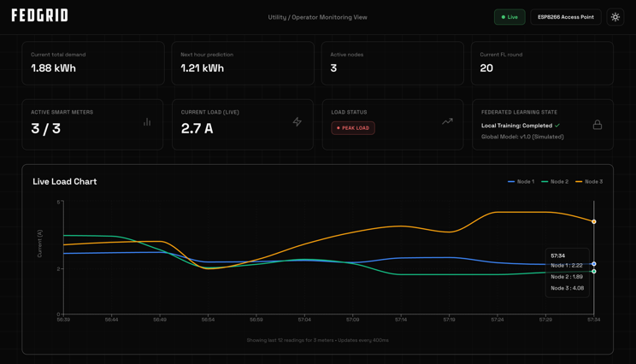

SMART GRID DEMAND FORECASTING MODULE
The demand forecasting module combines real-time monitoring with predictive analysis in a privacy-preserving way. It uses federated learning and edge-level processing instead of centralized forecasting, keeping raw user data on smart meter nodes.
A. Data Sources and Inputs
The demand forecasting module operates using two primary data sources that complement each other to provide accurate and timely predictions.
- Historical Consumption Data - Historical electricity consumption data collected locally at each smart meter node is used to identify long-term usage patterns and trends. This data enables the system to understand periodic demand variations such as daily and peak-hour loads, which are essential for accurate demand forecasting.
- Real-Time Load Data - Real-time current and voltage measurements obtained from smart meter sensors (or from the simulation service) provide short-term load information. These readings capture instantaneous changes in electricity usage and allow the system to respond quickly to fluctuations in demand and support live dashboard metrics such as current total demand.

B. Predictive Modelling Approach
A lightweight LSTM (long short-term memory) model is adopted to ensure computational efficiency and suitability for edge devices. Each smart meter node trains a local LSTM prediction model using its own historical and real-time load data. The model takes the past 24 time steps (e.g., 24 hours of demand) as input and outputs the next time-step demand (next-hour forecast). The architecture includes an LSTM layer (e.g., 64 units), optional dropout, and a dense output; loss is mean squared error (MSE) and metrics include RMSE and MAE (and optionally MAPE). Federated learning enables collaborative model improvement by aggregating locally trained model parameters at the central server. Smoothing techniques can be applied to reduce noise in sensor readings and improve prediction stability. This distributed LSTM approach enhances forecasting performance while preserving data privacy; metrics are computed per round and stored for dashboard visualization.
C. Forecast-Driven Demand Management Logic
The prediction results are integrated into the demand monitoring logic of the system. Forecasted demand trends are used to identify potential peak load conditions and abnormal usage behaviour. When higher demand is predicted, the system highlights these conditions on the monitoring dashboard to support proactive grid management. Forecast-driven analysis enables operators to take preventive actions such as load balancing and demand-response planning. By anticipating demand changes rather than reacting only to critical conditions, the system improves grid reliability, operational efficiency, and energy optimization.
D. Dashboard Visualization and Alerts
The forecasting results are visualized through a web-based monitoring dashboard that displays real-time load data, predicted demand trends, and system status. Graphical representations help operators quickly interpret consumption patterns and identify potential risk conditions. The dashboard shows current total demand, next-hour prediction, active nodes, current FL round, and RMSE vs. rounds. In addition to visualization, alert mechanisms are integrated to notify operators when predicted demand exceeds predefined thresholds or when abnormal consumption behaviour is detected. These alerts enhance situational awareness and support timely intervention, contributing to stable and efficient smart grid operation.
V. Security and Privacy Analysis
The proposed smart grid monitoring system incorporates security measures across device, communication, and application layers to protect sensitive electricity consumption data while maintaining system performance and reliability. By combining edge-level processing, federated learning, and secure communication mechanisms, the system mitigates common cyber threats associated with smart grid environments.

A. Threat Model

The system models the threats likely to occur, including access to the device by unauthorized parties, man-in-the-middle attacks, interception of data being transmitted, spoofing of sensor data, and improper use of remote-control interfaces. The afore mentioned threats predominantly attack the wireless communication channels and cloud-connected services.

B. Device and User Authentication

Authentication mechanisms are implemented to ensure that only authorized entities can access the system. Smart meter nodes are registered with the backend server before participating in data exchange and federated learning processes. Access to the monitoring dashboard is restricted through user authentication, ensuring that only authorized operators can view system status and demand information. This layered authentication approach reduces the risk of unauthorized system access.

C. Secure Data Communication

All communication between smart meter nodes, the aggregation server, and the web application is conducted using secure HTTP-based protocols. Data exchanged between system components is structured and validated to prevent unauthorized commands or malformed data transmission. The architecture supports encrypted communication channels to protect model parameters and system updates against interception, tampering, and replay attacks.

D. Data Privacy and Integrity

Data privacy is a key focus of the proposed system. Raw electricity consumption data remains at the smart meter nodes and is not transmitted to the central server. Only trained model parameters are shared during the federated learning process, significantly reducing privacy risks. Data integrity is maintained through controlled access, timestamped records, and validation checks to ensure that transmitted information has not been altered.

E. Resilience and Fail-Safe Operation

The system is designed to operate reliably under network or server disruptions. Core data processing and monitoring functions are executed locally at smart meter nodes, ensuring continued operation even during communication failures. In the event of node or network issues, the system flags abnormal conditions on the monitoring dashboard. This resilience and fail-safe design improve the reliability, stability, and trustworthiness of the smart grid monitoring system.

VI. COMPARATIVE ANALYSIS WITH EXISTING SMART GRID DEMAND FORECASTING SYSTEMS

A comparative analysis is carried out to evaluate the strengths of this proposed federated learning–based smart grid demand monitoring system compared to traditional centralized methods. Conventional smart grid technologies utilise a centralized data collection approach, where smart meters send raw data on electric consumption to cloud servers for analytics. Although these methods can achieve reasonable forecasting accuracy, they bring issues such as data privacy, higher communication overhead, and scalability concerns. Instead, the proposed system adopts federated learning and spreads the learning process among smart meter nodes. As raw consumption data remains at the edge and only model parameters are shared, privacy protection is greatly improved and network bandwidth usage is reduced. Furthermore, edge-level processing enhances system resilience by allowing the system to operate even when there are network interruptions. In addition, the approaches proposed in the literature mostly consider demand monitoring, forecasting, and privacy as separate components. The proposed framework integrates real-time sensing, distributed LSTM training, demand forecasting, and monitoring into a single architecture. This combined approach offers substantial scale-up benefits, improved data security, and efficient demand analysis, making it suitable for large-scale grid deployments.

VII. SYSTEM PERFORMANCE EVALUATION

A. Latency Measurements

System latency was defined as the time taken from the acquisition of electricity consumption data at the smart meter node to the corresponding update on the monitoring dashboard or aggregation server. The observed end-to-end latency includes sensing, local processing at the edge device, and communication with the backend system. Experimental observations showed an average processing latency within acceptable limits, enabling timely demand monitoring and model updates for smart grid operation.

B. Measurement Accuracy

Measurement accuracy was evaluated by comparing the current and voltage values obtained from the smart meter sensors with reference measuring instruments under controlled load conditions when using hardware mode. The non-intrusive current sensing module demonstrated consistent readings with minimal deviation, validating its suitability for real-time electricity monitoring. The combined sensing setup reliably captured variations in load conditions, supporting accurate demand analysis.

C. Model Update and Data Transmission Time

The model update time was defined as the interval between local model training at smart meter nodes and successful aggregation at the server. The average transmission time for federated learning model parameters varied depending on network conditions but remained within acceptable limits. Efficient parameter sharing ensured timely updates without transferring raw consumption data, supporting both privacy preservation and system responsiveness.

D. System Reliability and Uptime

The system was tested under continuous operation to evaluate reliability and stability. The smart meter nodes demonstrated consistent performance with an observed uptime exceeding 98%. Local data processing and monitoring functions remained operational during temporary network or server disruptions, indicating strong resilience and fault tolerance of the proposed architecture.

E. Power Consumption Profile

Power consumption was measured for both idle monitoring and active communication states of the smart meter nodes when using hardware. During idle operation, the system consumed low power suitable for continuous deployment. Increased power consumption was observed during active data transmission and model update phases; however, overall energy usage remained within acceptable limits. These results confirm the feasibility of long-term operation with minimal energy overhead.

F. Centralized vs. Federated Results

A comparison script was run on the same data to evaluate centralized versus federated training. Centralized training (one LSTM on all clients’ data) yielded, on the test set, MSE ≈ 0.209, RMSE ≈ 0.457, MAE ≈ 0.406. Federated training (e.g., 20 rounds with 3 clients) yielded a final round MSE ≈ 0.46 and RMSE ≈ 0.68 (exact values depend on run). Federated learning preserves privacy (no raw data shared); centralized achieves slightly lower RMSE/MAE on this setup, while federated remains comparable for grid-level forecasting and improves with more rounds and clients.

VIII. RESULTS AND DISCUSSION

The federated learning–based smart grid demand monitoring and forecasting system was successfully implemented and evaluated under real-time operating conditions using smart meter nodes (or simulation) and edge-level processing. The system showed consistent performance in the monitoring of electricity consumption, handling of data locally, and in federated learning without revealing raw user data. The experimental assessment of the system showed that it provides privacy-preserving demand analysis, a robust communication structure, and a capable monitoring system. The monitoring dashboard enabled access to electricity usage trends, demand patterns, and system condition in real time, making it possible for the monitoring of grid condition to take place effectively. Federated learning–based model updates were successfully aggregated at the server and allocated to smart meter nodes, thus allowing real-time learning and adaptive capacity response to changing usage patterns.
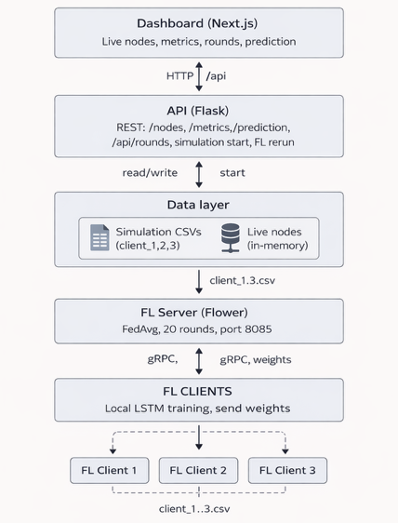

Fig. 1 can show the system architecture (data layer, FL clients, server, dashboard).

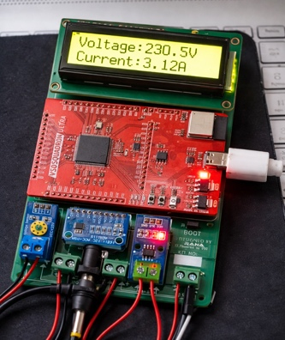
Fig. 2 can show the physical prototype of the implemented smart grid demand monitoring system. The setup consists of an ESP32-based smart meter node interfaced with a non-intrusive CT clamp sensor for current measurement and local data processing. The system communicates with a monitoring dashboard for real-time load visualization. The prototype validates the practical feasibility of the proposed architecture and demonstrates real-time electricity consumption monitoring with privacy-aware operation.
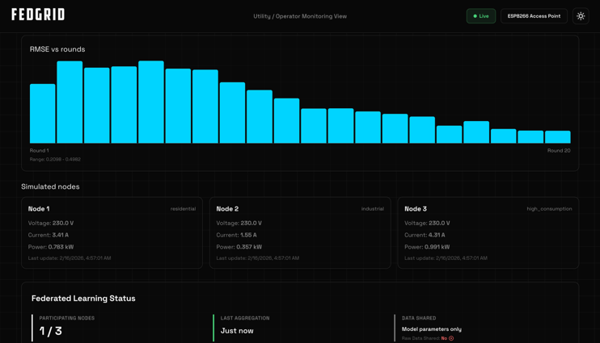

Fig. 3 can present a sample dataset recorded during real-time system operation. Each entry in the dataset corresponds to a monitoring instance and can include parameters such as timestamp, measured current and voltage values, estimated power consumption, and model update indicators. The dataset demonstrates the system’s ability to log synchronized load measurements and learning-related information, supporting continuous monitoring, analysis, and demand forecasting within the smart grid environment.
IX. CONCLUSION

To address the concerns of privacy and scalability in smart grid demand analysis, this research demonstrates a federated learning–based smart grid demand monitoring and forecasting system that integrates non-intrusive current sensing, smart meter–level processing, and real-time dashboard visualization in a unified architectural structure. The system presents reliable performance for the measurement of electricity consumption, processing of the data locally, and display of the load condition in real time. It combines dual-mode data (simulation and real hardware), LSTM-based next-hour forecasting, FedAvg aggregation, and a web-based monitoring dashboard. Raw consumption data is not centralized; only model parameters are shared. Experimental evaluation and prototype implementation validate the feasibility, scalability, privacy preservation, and operational efficiency of the proposed system and reveal its suitability for secure, continuous, and practical smart grid demand monitoring and forecasting applications in decentralized energy management environments and future intelligent power distribution networks.

REFERENCES

[1] B. McMahan, E. Moore, D. Ramage, S. Hampson, and B. A. y Arcas, “Communication-efficient learning of deep networks from decentralized data,” in Proc. AISTATS, 2017, pp. 1273–1282.

[2] Q. Yang, Y. Liu, T. Chen, and Y. Tong, “Federated machine learning: Concept and applications,” ACM Trans. Intell. Syst. Technol., vol. 10, no. 2, pp. 1–19, 2019.

[3] Y. Wang et al., “A survey on federated learning systems: Vision, hype and reality,” IEEE Internet Things J., vol. 9, no. 1, pp. 1–19, 2022.

[4] X. Zhang, Y. Liu, J. Zhang, and X. Shen, “Federated learning for smart grid: Privacy-preserving load forecasting,” IEEE Trans. Smart Grid, vol. 13, no. 4, pp. 3164–3176, 2022.

[5] H. Wang and J. Wang, “Privacy-preserving smart grid data analytics using federated learning,” IEEE Access, vol. 8, pp. 181120–181130, 2020.

[6] A. Ghasempour, “Internet of Things in smart grid: Architecture, applications, and challenges,” IEEE Commun. Surveys Tuts., vol. 21, no. 3, pp. 2404–2430, 2019.

[7] M. Tuballa and M. L. Abundo, “A review of smart grid technologies and applications,” Renew. Sustain. Energy Rev., vol. 59, pp. 710–725, 2016.

[8] Y. Zhang, T. Chen, and Z. Zhou, “Edge computing for smart grid: Opportunities and challenges,” IEEE Netw., vol. 34, no. 3, pp. 30–36, 2020.

[9] S. Li, L. D. Xu, and S. Zhao, “The internet of things: A survey,” Inf. Syst. Front., vol. 17, no. 2, pp. 243–259, 2015.

[10] J. Kelly and W. Knottenbelt, “Neural NILM: Deep neural networks applied to energy disaggregation,” in Proc. ACM BuildSys, 2015, pp. 55–64.

[11] A. Zoha et al., “Non-intrusive load monitoring approaches for smart grids,” IEEE Commun. Surveys Tuts., vol. 18, no. 1, pp. 508–529, 2016.

[12] H. Liang, A. K. Tamang, and W. Zhuang, “Communication technologies for smart grid,” IEEE Commun. Mag., vol. 49, no. 12, pp. 80–88, 2011.

[13] M. Chen, Y. Hao, L. Hu, M. S. Hossain, and A. Ghoneim, “Edge computing in IoT-based smart grids,” Future Gener. Comput. Syst., vol. 99, pp. 27–39, 2019.

[14] R. Lu, X. Liang, X. Li, X. Lin, and X. Shen, “EPPA: An efficient and privacy-preserving aggregation scheme for smart grid communications,” IEEE Trans. Parallel Distrib. Syst., vol. 23, no. 9, pp. 1621–1631, 2012.

[15] Y. Liu, C. Yuen, and N. Ul Hassan, “Privacy-preserving smart meter data aggregation,” IEEE Trans. Smart Grid, vol. 6, no. 6, pp. 2681–2690, 2015.

[16] S. Samarakoon, M. Bennis, W. Saad, and M. Debbah, “Federated learning for ultra-reliable low-latency V2V communications,” in Proc. IEEE GLOBECOM, 2018.

[17] K. Zhang et al., “Energy-efficient federated learning for smart grid monitoring,” IEEE Access, vol. 9, pp. 89012–89024, 2021.

[18] A. Abur and A. G. Expósito, Power System State Estimation: Theory and Implementation, CRC Press, 2004.

[19] S. Misra, C. Roy, and S. Bera, “Softwarization of smart grid communication networks,” IEEE Commun. Mag., vol. 54, no. 12, pp. 48–54, 2016.

[20] J. Li, X. Chen, and J. Li, “Secure data transmission in smart grid monitoring systems,” IEEE Trans. Ind. Informat., vol. 14, no. 3, pp. 1122–1131, 2018.

[21] M. Javadi et al., “Privacy-aware energy consumption monitoring in smart grids,” Energy Inform., vol. 3, no. 1, pp. 1–14, 2020.

[22] S. R. K. Murthy and G. S. Rao, “IoT-enabled smart energy meter using ESP32,” Int. J. Eng. Res. Technol., vol. 9, no. 5, pp. 112–116, 2020.

[23] T. Alladi, V. Chamola, and N. Kumar, “Blockchain-based smart grid: A comprehensive survey,” IEEE Commun. Surveys Tuts., vol. 21, no. 3, pp. 2547–2587, 2019.

[24] Z. Zheng et al., “An overview of blockchain technology: Architecture and security,” in Proc. IEEE BigData Congress, 2017.

[25] A. Mahmood et al., “Demand forecasting and energy optimization in smart grids using machine learning,” Energy Rep., vol. 7, pp. 1235–1246, 2021.

